Бушуев Андрей Павлович ПМИ-РКС-20

select \*

from customers

where city != ‘Ковров’

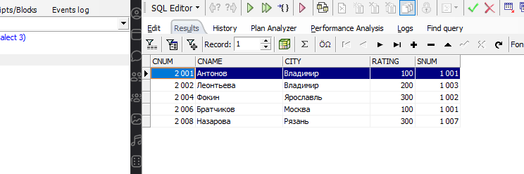

select \*

from orders

where odate = '03.10.2006' or odate = '04.10.2006'

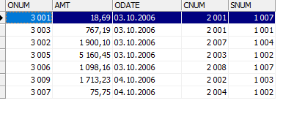

select min (amt)

from orders

where cnum = 2008

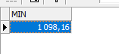

select avg(amt)

from orders

where cnum = 2003 or cnum = 2007



select count(cnum), snum

from orders

group by snum

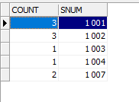

select salespeople.sname, max(orders.amt)

from salespeople

left outer join orders on salespeople.snum = orders.snum

group by salespeople.sname

order by salespeople.sname

